- In order to call a function that is stored in a module, you have to write an import statement at the top of your program. Import statement tells the interpreter the name of the module that contains the function that you are going to use. For instance if we want to use sqrt function which calculates square root of a number we have to write the “import math” statement at the top of our program. Write the following function in C++.

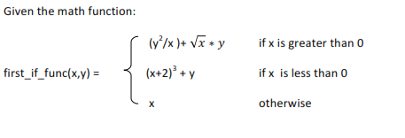

- You are tasked with writing a function, mortgage_approval, which aims to approve or decline a mortgage loan. The function should take as parameters 6 pieces of information about the mortgage applicant: the loan amount they are applying for, their current yearly salary, their current cash in accounts, their estimated non cash assets, a numerical credit score, and a last name. The function should return True if the loan was approved, False otherwise. You are given the following business rules to guide the process:
  - No mortgage will be approved if the applicant has less than 10% of the loan amount as cash in accounts.
  - No mortgage will be approved if the applicant has less than a credit score of 600.
  - For applicants with credit scores between 600 and 700, current cash in accounts must be greater thanor equal to 20% of the loan amount.
  - All applicants must have yearly salary greater than one-tenth of the balance of the loan, which is considered to be the loan amount minus the cash in accounts.

3. Write a program that calculates and displays the average of a group of test scores, all integers, where the lowest score in the group is dropped. There are six test scores in the group. The program must use the following functions:
getScores() must be called by the main function and should ask the user for the six test scores and return them.
calcAverage() should calculate and return the average of the five highest scores and also the lowest of the six test scores. This function should be called just once by the main function, and should be passed the six scores.
findLowest() should find and return the lowest of the six scores passed to it. It must be called by calcAverage function, which uses it to determine which of the six scores to drop. (Do NOT use any built-in function)

